**FUNCTIONAL REQUIREMENTS OF CAR RENTAL SYSTEM**

**OBJECTIVE:**

The main objective of the Car Rental System is to manage the details of Car ,Payment, Customer, Admin. It manages all the information about Car, Booking , Modifying ,etc. The project is totally built at administrative end and Customers end thus both the administrator and customer is guaranteed the access. The purpose of the project is to build an application program to reduce the manual work for managing the Car, Payment, Booking Reservation, Customer. It tracks all the details about the Customer.

**FEATURES SUPPORTED IN APPLICATION:**

**FEATURES AVAILABLE FOR ADMIN:**

1. VIEW BOOKING
2. MODIFY BOOKING
3. ADD STAFF
4. PAYMENT STATUS

**FEATURES AVAILABLE FOR USERS:**

1. BOOKING FOR RENT
2. ADD/MODIFY BOOKING
3. VIEW STATUS
4. SEARCH CARS
5. CUSTOMER SUPPORT

**FEATURES FOR ADMIN:**

Login->Dashboard>View Booking

Login->Dashboard->Modify Booking

Login->Dashboard->Add Staff

Login->Dashboard->Payment Status

|  |  |
| --- | --- |
| **View Booking** | Allows the admin to view the customers booking history , id ,payment ,booking time and date. |
| **Modify Booking** | Allows the admin to modify booking details of customer like cancel booking ,changing car ,pick up and end date and time. |
| **Add Staff** | Allows the admin to add staff to approve the customers request for booking and Payment. |
| **Payment Status** | Allows the admin to check payment status of the customer or If the payment has to done by the admin for the customer. |

**FEATURES FOR USERS:**

Login->Dashboard->Booking For Rent->Pick Up Time->Destination Location

Login->Dashboard->Modify Booking

Login->Dashboard->View Status

Login->Dashboard->Current Location

Login->Dashboard->Customer Support

|  |  |
| --- | --- |
| **Booking For Rent** | Allows User To Book the cars at specified destination ,location ,Time , date. It contains search for cars availability. |
| **Modify Booking** | Allows User To Modify Booking such as cancel booking ,updating date and time. |
| **View Status** | Allows User to View Status of their booking. |
| **Current Location** | Allows User to see his/her Current location(availability) |
| **Customer Support** | Allows User to Contact Customer Support. |

**ADMIN INTERACTIONS:**

1)Admin can View Booking details of the customer

2)Admin can Modify Booking details of the customer

3)Admin can Add Staff

4)Admin can check payment status of the customer

5)Admin can logout.

**USER INTERACTIONS:**

1.User can click on Booking For Rent from Customer Dashboard.

2.User can add the reservation details and click next.

3.User can add the customer details and click next.

4.User can select car type from car details.

5. User can agree for the terms and condition and proceed to payment window.

6. User can scan the QR code and payment can be done.

7.User can logout.

Admin Workflow:-

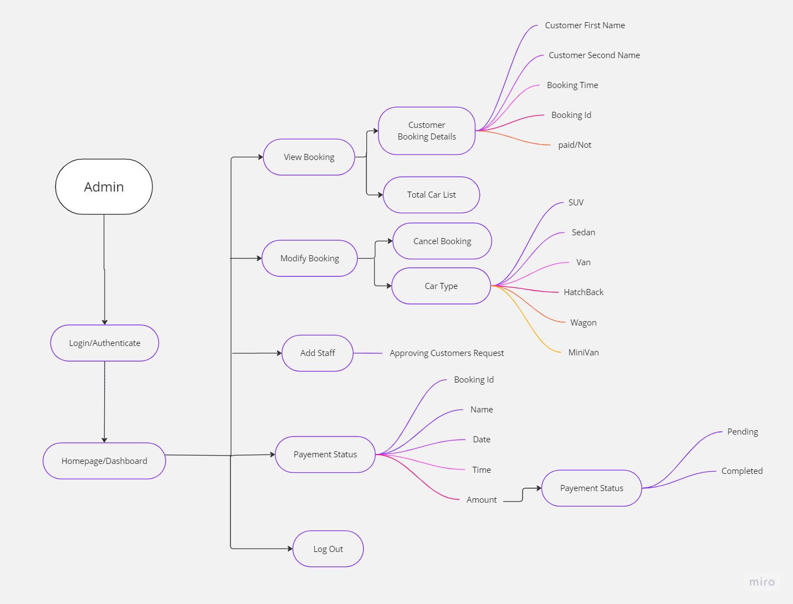

User Workflow:-

